**BC in a Box Goes to Alberta!**

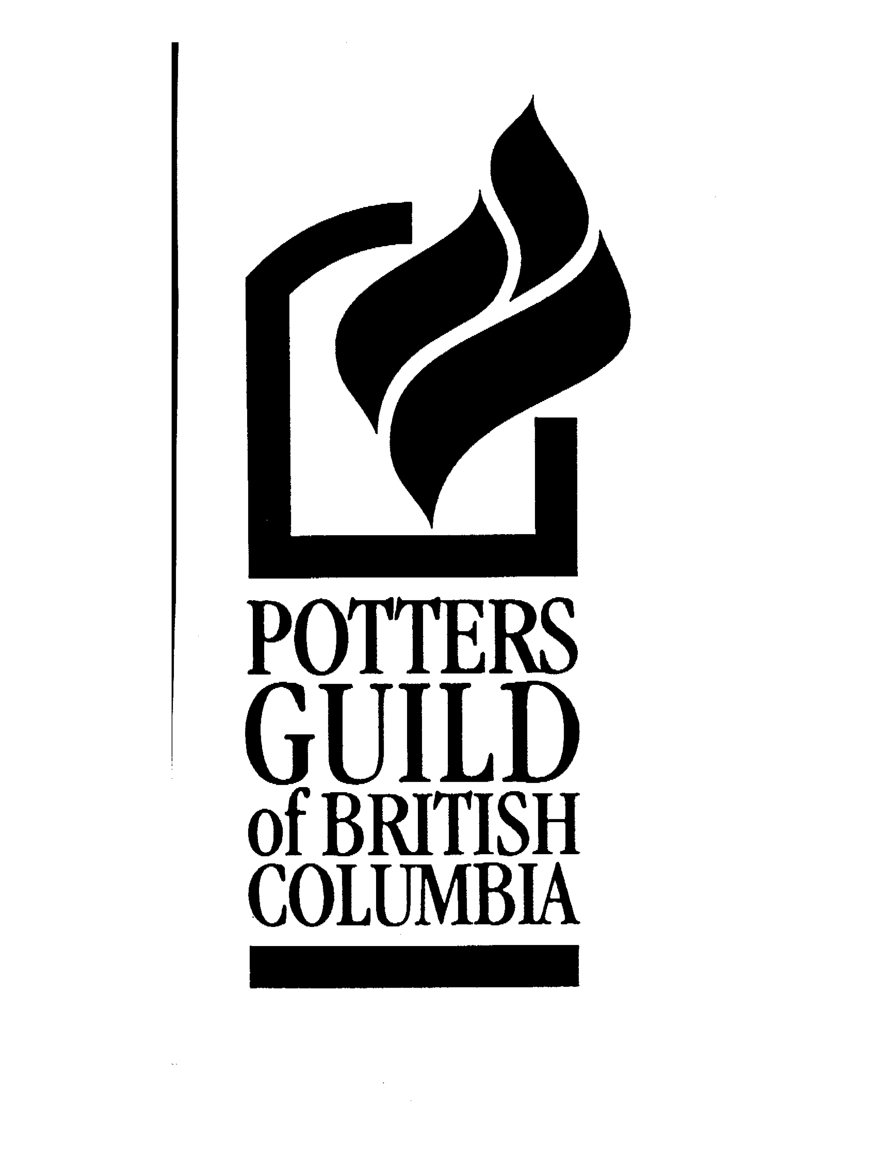

In exchange with the Alberta Potters Association, the Potters Guild of British Columbia is pleased to present a juried travelling show for members.

**Theme:** BC in a Box 3 - “The Edge of Here”

**Guidelines:**

* Pieces must fit, well wrapped, into a box with interior dimensions of 4 ½” x 4 ½” x 4 ½”.
* Pieces must have been made in 2010 or 2011
* Open to PGBC members in good standing.

**Dates:**

* May 15 – June 1st – submit entry form and images
* July –accepted works sent to the Gallery of BC Ceramics
* Sept. to Nov. – works shown in venues in Alberta
* Still pending – March 2012 – NCECA Seattle

**Jury Fee:** $25.00

For more details, please visit: [www.bcpotters.com/Guild/callsforentry_guild.php](http://www.bcpotters.com/Guild/callsforentry_guild.php)